Online Accessibility Tips: Documents, Slides, and Course Content

Quality Matters updated to the 6th Edition Rubric and Standards July 2018. Standards 8.1 – 8.6 address accessibility and usability. The following tips will help make your Microsoft Office documents and slides screen reader accessible. Always consult with your campus authority concerning accessibility and compliance with federal mandates.
*These items also apply to your online course content.
Item | Recommendation | Example
Document headings and subheadings | Use Text Styles on the Word Ribbon Bar | 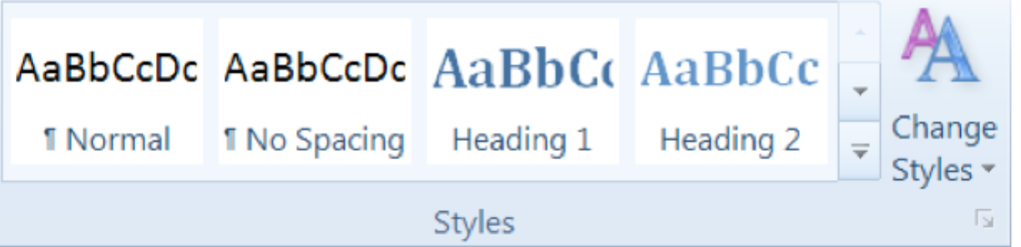  Style Ribbon 1
Text* | Use dark font colors on light backgrounds (preferably black text on white background). Avoid bright background colors.  Use the following fonts for easy readability and use one font for consistency: Times New Roman, Verdana, Arial, Tahoma, Helvetica, or Calibri.  Text should be minimum of 11 points. | 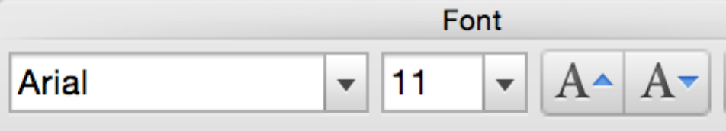  Sample Text
Emphasized text* | Use CAPS, bold, Italics or high- contrast color, but be sure that color is not the only means of conveying emphasis. Do not overuse.  DO NOT USE underlined text, as underlined text should only be used for hyperlinks. | 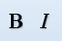  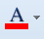
Tables* | Use tables when displaying text in columns and rows.  Provide column and row headers. Avoid spanning rows and columns (If possible) and using blank cells for formatting. | 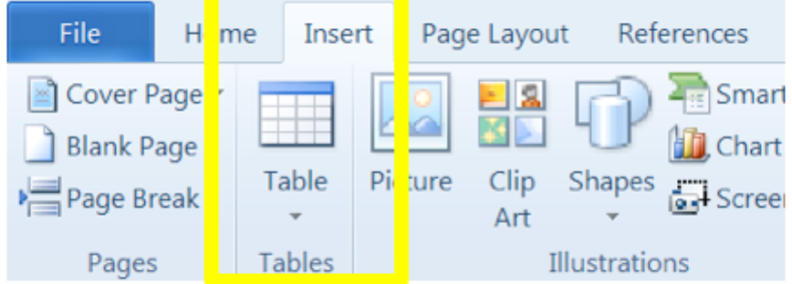
Images* | Use Alt Text to provide a brief description of the picture. This should also be used for graphs, diagrams, photos, tables, etc.  STEPS:  1. Right Click the picture  and select Format Picture  (or Format Object).  2. Select Alt Text.  3. Enter a title.  4. Enter a description of the picture if further explanation is needed.  5. The text conveyed in the image should also be explained in your document or presentation.  Note: It is not necessary to include “image of…” to describe an image.  Limit animated or blinking images to only those that support course content. | 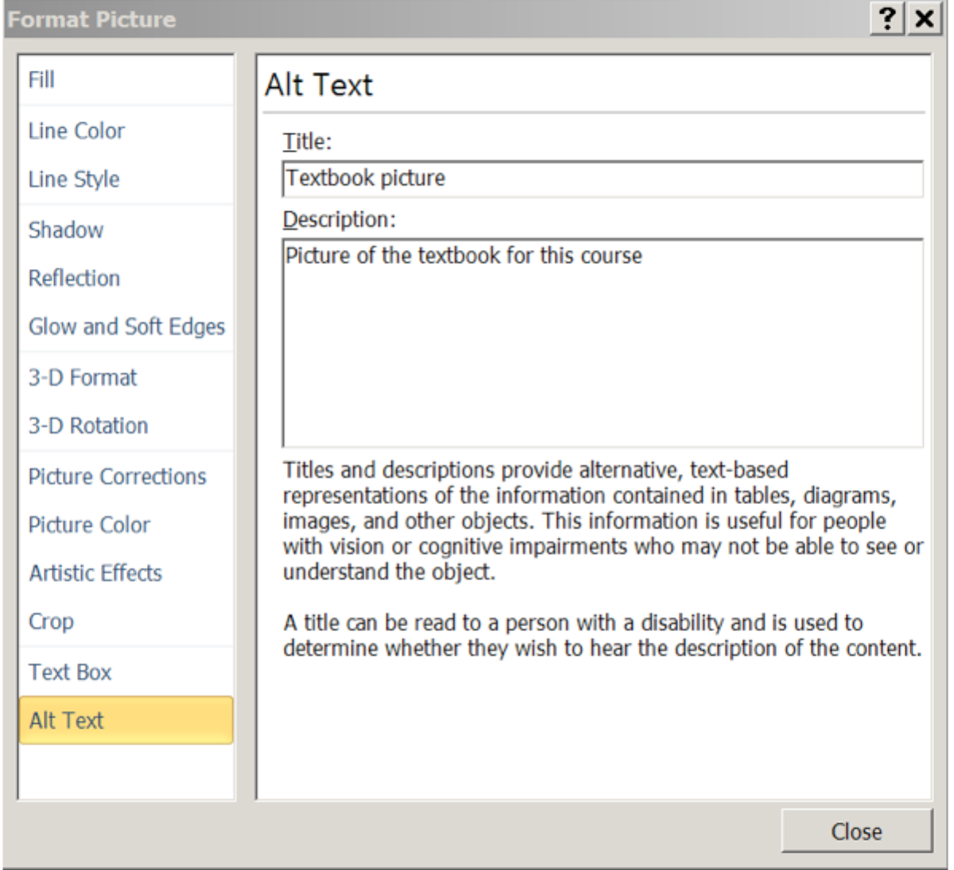
Hyperlinks* | Use meaningful words to describe your hyperlinks. Do not use “Click here.”
Embedded Blanks* | Avoid using spaces, blanks, tabs, and/or empty paragraphs to create white space. These read as “blanks” via screenreader. Instead, use indentations and paragraph spacing. | 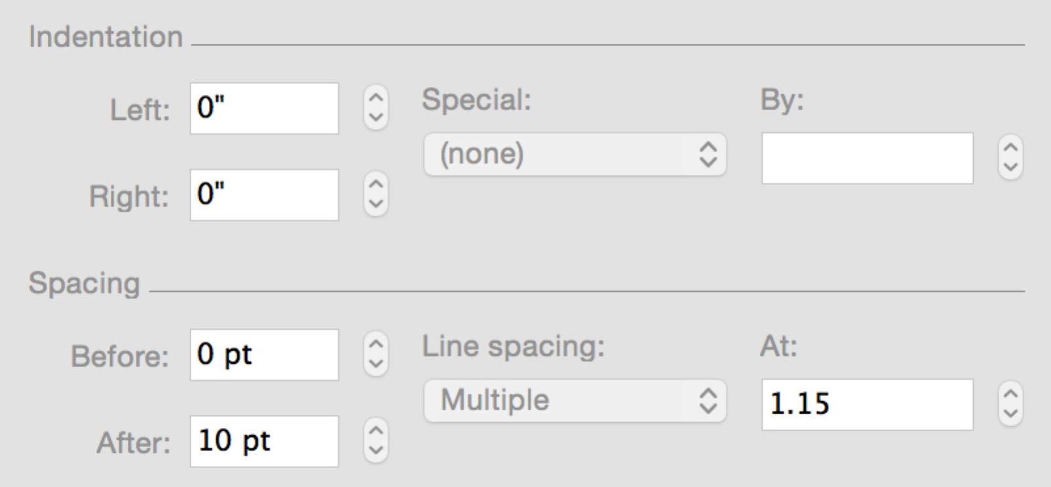
Reading Order | Make sure that all text and images are in the correct order for the screenreader. All images should be set as “in line with text” when you right click and select “format image.” | 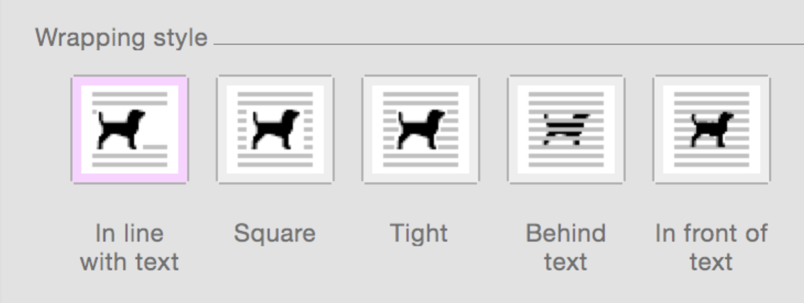

  - PowerPoint-Specific Items
Item | Recommendation | Example
Slide elements (multiple items that appear sequentially when clicked) | Be sure that items on the slide are in the correct reading order.  Example: Text placeholder 3 should be read before text placeholder 4. If these items are not in their correct order, then move using the arrows at the bottom. | 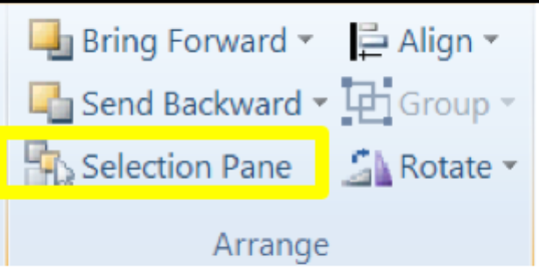  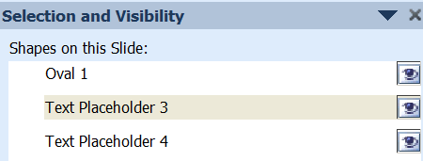
Use unique titles for all slides | In PowerPoint Outline View, set slide titles for each slide. | 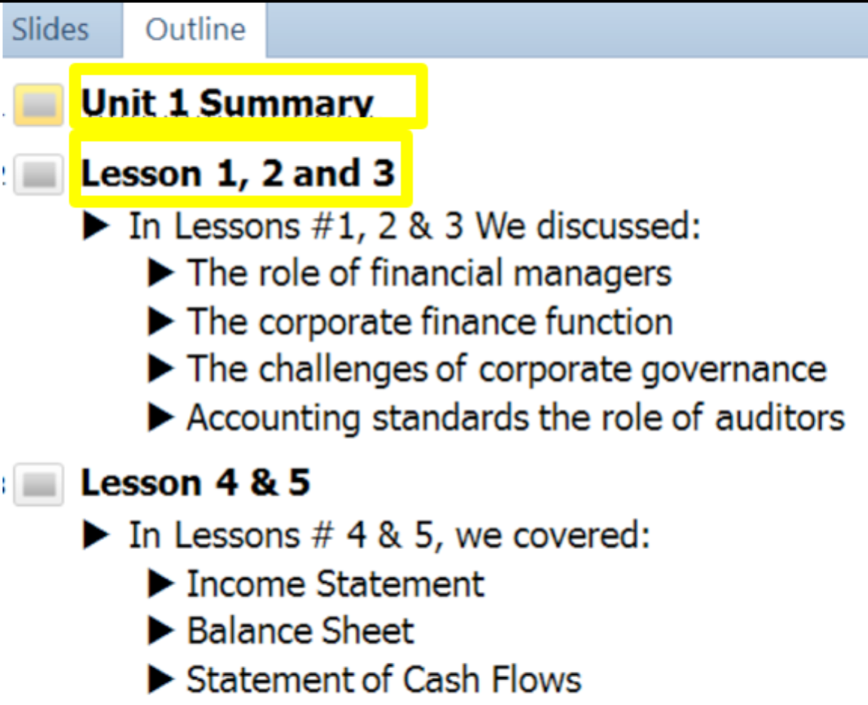
Fonts for  PowerPoint  Slides | Font Size: use 18 point or larger  Font Type: a Sans Serif font type for best online viewing (Arial, Calibri, Tahoma, Gothic, etc.)  Remember to leave white space on your slides. | 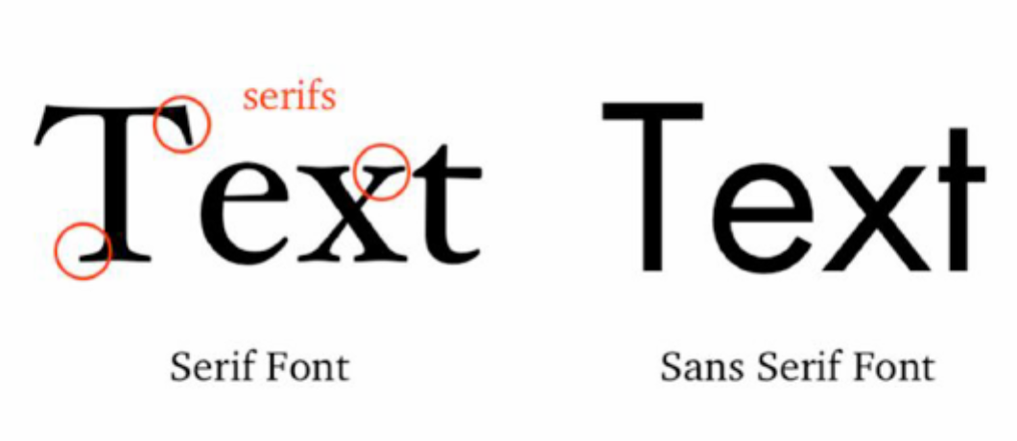
Please note: Current slides created by book publishers may have addressed many of these items already.
Microsoft Word and PowerPoint also have an Accessibility Checking tool that you can use to identify any issues in your document/slides.
Step 1. Go to the File Menu and click Check for Issues
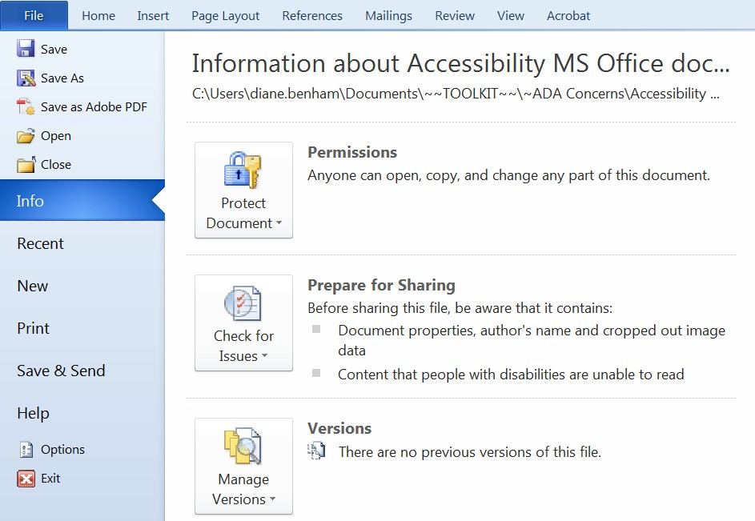

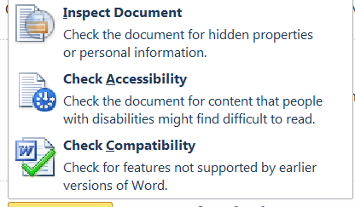
Step 2. Select Check Accessibility from the Drop-down list.

Step 3. Review each item in the Accessibility Checker list and make the recommended adjustment to better enable accessibility in your document/slides (see How to Fix section at the bottom).
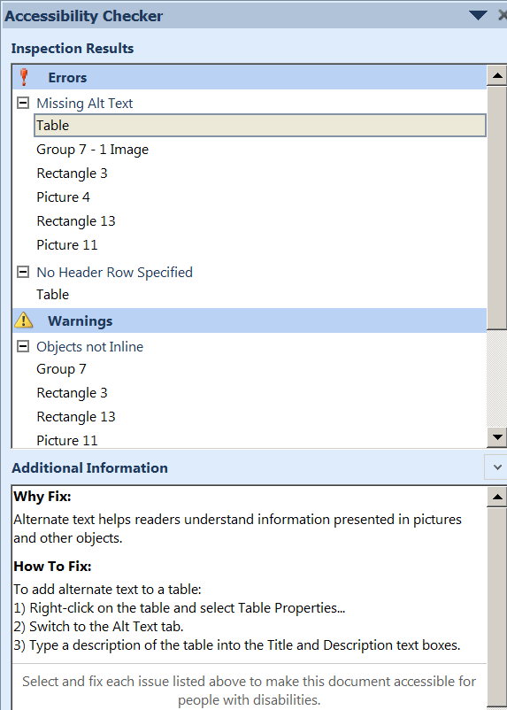

Additional Resources

Making Word Accessible Checklist: https://www.hhs.gov/web/section-508/making-files-accessible/checklist/word/index.html
Tutorial for Textual Images: https://www.w3.org/WAI/tutorials/images/textual/
Headings: https://webaim.org/techniques/word/#headings
Text Layout: https://webaim.org/techniques/textlayout/
Font: https://webaim.org/techniques/textlayout/
Hypertext: https://webaim.org/techniques/fonts/
Reading Order/Screenreader: https://webaim.org/techniques/screenreader/
Tables: https://webaim.org/techniques/tables/
Captions: https://webaim.org/techniques/tables/
Images: https://webaim.org/techniques/images/
Alt Text: https://webaim.org/techniques/alttext/
Microsoft Word: https://webaim.org/techniques/word/
Microsoft PowerPoint: https://webaim.org/techniques/powerpoint/
Adobe PDF: https://webaim.org/techniques/acrobat/
508 Checker (enter in website to run full accessibility check for free): http://www.508checker.com/
WAVE (Chrome extension): http://wave.webaim.org/extension/
UDOIT (Online content inspection tool runs free report on a course): https://cdl.ucf.edu/teach/accessibility/udoit/

